LECTURE 1

What is a Database?
A database is a collection of related data stored in a computer in an organized way so that it can be easily accessed, managed, and updated.
Simple explanation:
A database is like a digital cupboard where information is stored neatly, so we can quickly find and change it when needed.
Key points:
- Data is stored electronically
- Data is related (not random)
- Data is stored permanently (persistent)
- Data can be searched, added, updated, or deleted
Example:
- Student database → stores student name, roll number, marks
- Bank database → stores account details, balance, transactions

Database Definitions
Different definitions explain the same idea in different ways:
Common idea in all definitions:
A database is:
- A collection of data
- Stored in a computer
- Organized for fast access and retrieval
Important clarification (extra explanation):
⚠️ A database is NOT an application
✔️ A DBMS is the application
✔️ A database is the data itself
Types of Data in Databases:
- Structured Data
  - Has a fixed structure
  - Stored in tables (rows and columns)
  - Example: student records, employee table
- Unstructured Data
  - No fixed format
  - Example: text files, images, videos

Examples of Databases
Databases are used almost everywhere in daily life.
Common examples:
- Web search engines (Google index)
- Library catalog systems
- Medical records in hospitals
- Bank accounts
- Stock and inventory systems
- Employee and payroll systems
- Student records in universities
- Airline booking systems
- Credit card systems
- Customer records in companies
Why these need databases?
- Large amount of data
- Data must be accurate
- Fast searching and updating is required
- Data security is important

Database Systems
A database system is more than just data.
A database system consists of:
- Data – the actual stored information
- Software – DBMS
- Hardware – computers, storage devices
- Users – people who use the system
📌 In DBMS course, we mostly focus on the software part (DBMS).
What database systems allow users to do:
- Store data
- Update data
- Retrieve data
- Organize data
- Protect data from unauthorized access

Database Management System (DBMS)
A DBMS is software that:
- Controls the database
- Manages data storage
- Allows users to access data in a safe and controlled way
Simple explanation:
DBMS is like a manager that takes care of data and decides:
- Who can see the data
- Who can change the data
- How data is stored and retrieved
Examples of DBMS:
- MySQL
- Oracle
- PostgreSQL
- MS SQL Server
- MS Access
Main functions of a DBMS:
- Create databases
- Store data
- Retrieve data quickly
- Update and delete data
- Provide security
- Maintain data integrity

Metadata
Metadata means data about data.
It describes the structure and properties of the actual data stored in a database.
Metadata tells us:
- What tables exist in the database
- What columns each table has
- Data type of each column (integer, text, date, etc.)
- Size of fields
- Rules and constraints on data
Example:
If a table is called Student, then metadata includes:
- Table name: Student
- Column names: RollNo, Name, Age
- Data types: Integer, Varchar, Integer
Why metadata is needed:
- Helps the DBMS understand how data is stored
- Makes data easier to manage and maintain
- Allows programs and users to use data correctly
- Supports data independence
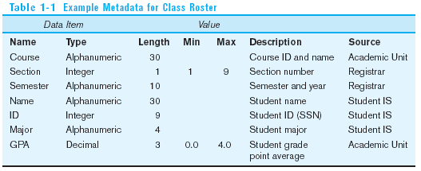
Data Dictionary
A data dictionary is a central storage of metadata.
It stores information about the database itself.
In simple words, a data dictionary is a catalog that describes the database.
It contains:
- Table names and column details
- Data types and sizes
- Indexes and views
- Users and access permissions
- Schema information
- Information about data usage (such as locks)
Why data dictionary is important:
- Almost every DBMS operation uses it
- Helps maintain consistency in the database
- Supports security and access control
- Helps database administrators manage the database
The data dictionary is maintained automatically by the DBMS.

File-Based Systems
In a file-based system, data is stored in separate files.
Each file:
- Has its own format
- Is designed for a specific application
- Is directly accessed by programs
In this system:
- Programs must know the structure of the file
- Data and programs are tightly connected
Example:
A payroll system and a student system may store employee data separately in different files.

Disadvantages of File Processing Systems
File-based systems have many problems, especially when data becomes large.
Main disadvantages include:
- No standard way to store data
- Same data stored in multiple files
- Data depends heavily on programs
- No proper security
- No support for recovery if data is lost
- No support for multiple users at the same time
- Difficult to generate ad-hoc queries
These problems make file-based systems inefficient and hard to manage.

Problems with Data Dependency
Data dependency means that programs depend on the structure of data files.
Problems caused by data dependency:
- Each application program must maintain its own metadata
- Any change in file structure requires changes in all related programs
- Programs must include their own code for reading, inserting, updating, and deleting data
- Lack of central control over data
- File formats are not standardized
This results in:
- Increased development time
- High maintenance cost
- Greater chance of errors
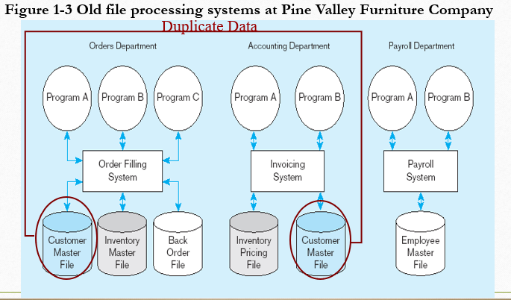

Problems with Data Redundancy
Data redundancy means that the same data is stored in more than one place.
Example:
A student’s address stored in admission records, exam records, and library records.
Problems caused by data redundancy:
- Extra storage space is wasted
- Updating data becomes difficult
- Same data must be updated in many files
- Increases maintenance cost
- Causes data inconsistency
Data inconsistency occurs when:
- Data is updated in one file
- But not updated in another file
This results in incorrect and unreliable information.

Database Approach (Solution)
The database approach is used to solve the problems of file-based systems, especially data redundancy and data dependency.
In this approach:
- Data is stored in a central database
- Data is shared among multiple applications
- A DBMS controls and manages the data
- Data is stored in a standardized and organized form
The DBMS acts as a controlling agent that:
- Manages data storage
- Controls data access
- Ensures data consistency and security

Advantages of the Database Approach
The database approach provides many benefits.
Main advantages:
- Program-data independence: Programs are not affected by changes in data structure.
- Reduced data redundancy: Data is stored only once.
- Improved data consistency: Updates are reflected everywhere.
- Better data security: Only authorized users can access data.
- Improved data sharing: Multiple users can use the same data.
- Role-based access control: Different users have different permissions.
- Data concurrency: Many users can access data at the same time.
- Reduced program maintenance: Less time and cost for updates.
- Improved data accessibility: Faster and easier data retrieval.
- Data privacy is maintained

What is a DBMS?
A Database Management System (DBMS) is software that manages and controls a database.
It allows users to:
- Store data
- Retrieve data
- Update data
- Delete data
- Access data securely
In simple words, a DBMS acts as a bridge between users and the database.
Examples of DBMS:
- MySQL
- Oracle
- PostgreSQL
- MS SQL Server
- MS Access
A DBMS ensures data is secure, consistent, and easily accessible.

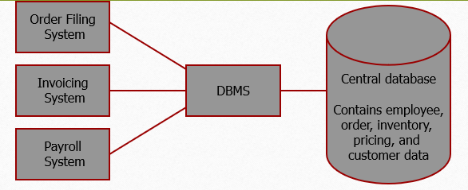

Functions of a DBMS
Data Definition Language (DDL)
DDL is used to define the structure of the database. It helps create tables, fields, and relationships.
Data Manipulation Language (DML)
DML is used to insert, update, delete, and retrieve data from the database.
Data Control Language (DCL)
DCL is used to control access to data. It manages user permissions and authorization.
Concurrency Control
The DBMS allows multiple users to access the database at the same time without conflicts.
Data Integrity
The DBMS ensures that data remains correct, accurate, and consistent.
Data Security
The DBMS protects data from unauthorized access.
Data Independence
Changes in database structure do not affect application programs.
Data Dictionary
The DBMS maintains a data dictionary that stores metadata, which is data about data.

Database Users
Database users are people who interact with the database system in different ways to store, access, and manage data.
Different users have different responsibilities and access levels in a database system.

Types of Database Users
End Users
End users use the database system to perform their daily tasks. They usually interact with the database through applications.
Application Developers
Application developers write programs that allow end users to interact with the database easily.
Database Administrator (DBA)
The DBA is responsible for managing, controlling, and maintaining the database system.
Database Designer
The database designer designs the structure of the database, including tables, relationships, and constraints.
End Users
End users are people who use the database but do not manage it.
Naïve Users
Users who interact with the database through predefined applications without knowing DBMS details.
Example: A cashier using a billing system.
Casual Users
Users who occasionally query the database using SQL or simple tools.
Example: A manager generating monthly sales reports.
Sophisticated Users
Users who write complex queries, develop applications, or analyze data deeply.
Example: A data scientist running machine learning queries on a customer database.
Stand-Alone Users
Users who maintain personal databases using custom programs without a DBMS expert.
Example: A researcher using MS Access for research records.
Note:
- Naïve users use predefined applications without knowing DBMS details, while casual users occasionally query the database using simple SQL or tools.
- Sophisticated users work with complex, shared databases using advanced queries, while stand-alone users manage small personal databases using simple tools like MS Access.

